AI Statement: I did this work on my own
Project title: Body Composition and Cardiometabolic Health among South Asians: Distribution, Correlates, and Associations with Outcomes in the BELIEVE Cohort in Bangladesh

Questions for reflection
- Which aspects of this assignment are you most uncertain about and/or would most like to receive feedback on?

- What questions are you left pondering after this assignment that you would like to discuss further?

- How have you incorporated feedback from peers / supervisors into this assignment?

- I have had multiple discussion with my supervisor about scope and I have narrowed the focus of this dissertation to fit the timeline of my Mphil. As opposed to focusing on 8 cardiometabolic outcomes I have chosen to focus on majorly one
- Even if I have studied a number of analysis model I am going to use my supervisor has asked me guided questions that have framed my current approach that will be built on in my classes

- How, and to what extent, have you been able to incorporate feedback on previous assignments into this assignment?

Table of Contents
1 Introduction 2
2 Overall Aim 6
2.1 Research Objectives 6
3 Methods 6
3.1 Study design and setting 6
3.2 Study population and follow-up 7
3.3 Exposures 8
3.4 Outcomes 8
3.5 Covariates and confounders 8
3.6 Statistical analysis 8
3.6.1 Assessment of normality 8
3.6.2 Research aim 1: Descriptive analyses 9
3.6.3 Research aim 2: Cross-sectional associations 9
3.6.4 Model assumptions and effect modification 9
3.6.5 Research aim 3: Longitudinal analyses 10
3.6.6 Cox Proportional Hazards Assumptions 10
3.7 Handling of missing data 10
4 Discussion 10
5 Risk assessment and contingency plans 11
6 Timeline 12
7 Appendix 13
8 References 15

Table of Figures
Figure 1: Multidimensional drivers of cardiometablic disease in South Asians 3
Figure 2: Body composition measures using BIA 4
Figure 3: BELIEVE Study design and procedures 6
Figure 4: Location of the BELIEVE study sites. 7

Introduction
South Asia bears a disproportionate burden of cardiovascular disease, type 2 diabetes, and metabolic syndrome (1–3), characterized by earlier disease onset and elevated cardiometabolic risk at lower Body Mass Index (BMI) relative to other global populations (4,5). In recognition of this, the World Health Organization (WHO) recommends lower BMI thresholds for Asians, defining increased risk at 23 kg/m² and high risk at 27.5 kg/m² (6). However, BMI does not accurately reflect visceral fat, which plays a crucial role in cardiovascular and metabolic risk (7–9). A crucial manifestation of this is the Normal Weight Obesity (NWO) phenotype, where individuals with normal BMI (18.5–24.9 kg/m²) possess elevated percentage body fat, predisposing them to insulin resistance, dyslipidemia, and hypertension (10–12). Because BMI-based screening classifies these individuals as low risk, many remain clinically undiagnosed (13,14). In Bangladesh (Figure 1), cardiometabolic risk reflects the interaction of biological factors (dyslipidemia, obesity), behavioural factors (high-fat diet, tobacco use, physical inactivity), and environmental factors like air pollution (15,16). These risks are further amplified by rapid, unplanned urbanization, socioeconomic deprivation, and constrained health system capacity (17,18). Together this complex risk profile, coupled with low awareness, and critical screening gaps undermine the efficient use of scarce health resources for identifying individuals at high cardiometabolic risk(19,20).
Figure 1: Multidimensional drivers of cardiometablic disease in South Asians
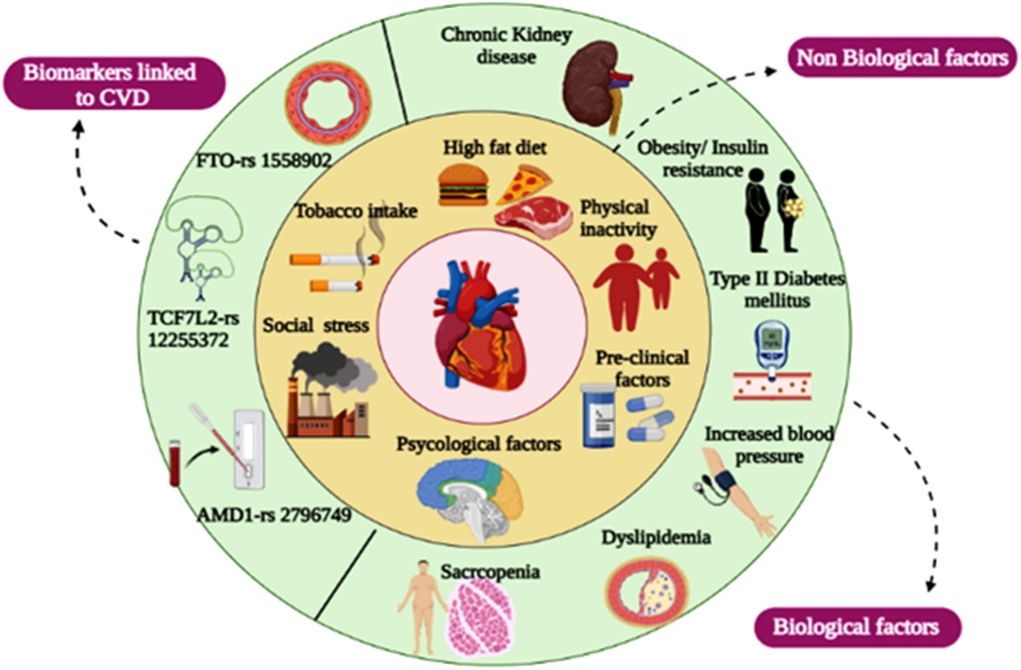
Source: Bhotla HK Curr Probl Cardiol 2024(49)102071
Assessment of body composition provides additional information not captured by a global measure as BMI (Figure 2), including quantification of fat mass, fat distribution, lean mass and other characteristics (21) that can be effective in identifying individuals at risk (17,22). While imaging modalities such as Magnetic Resonance Imaging (MRI), Computed Tomography (CT), or Dual-energy X-ray absorptiometry (DXA) scans are the gold standard for body composition assessment, their high cost, limited availability, and technical requirements limit use in LMICs (23,24). In contrast, Bioelectrical impedance analysis (BIA), provides a relatively simple, inexpensive, and non-invasive method to estimate body composition in large populations (25,26). BIA measures electrical impedance of low level electrical current passing through body tissues allowing derivation of body composition indices. Although BIA derived estimates are influenced by hydration status, recent food intake, physical temperature, and ethnic differences (21,27), multiple validation studies have demonstrated strong correlations between BIA and reference methods such as DXA and CT (28–30). Moreover BIA-derived body composition measures have been associated with cardio-metabolic risk factors and outcomes in China, Israel, Colombia, and Scotland supporting its utility in epidemiological research in LMICs (31–34).
Figure 2: Body composition measures using BIA
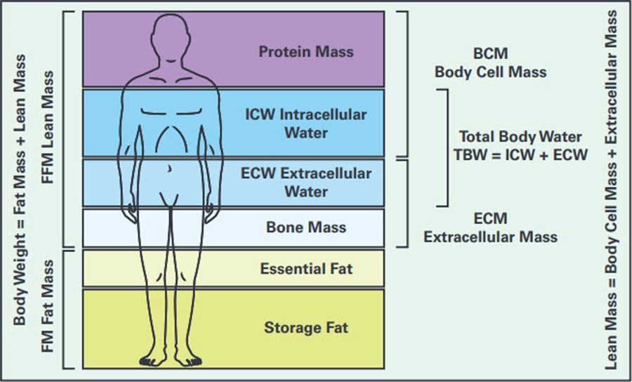
Despite this growing evidence, there is limited large-scale population-based evidence from South Asian LMICs linking BIA-derived body composition to cardio-metabolic disease. The BangladEsh Longitudinal Investigation of Emerging Vascular and Nonvascular Events (BELIEVE) cohort study (4) addresses this gap. BELIEVE is a large, household-based prospective cohort study of natives in Bangladesh across urban, urban-poor(slum), and rural settings with extensive epidemiological, behavioural, and clinical information collected using standardised protocols (Figure 3). This cohort enables detailed characterization of body composition measures across sociodemographic strata and examination of its association with prevalence and incidence of cardiometabolic diseases and multimorbidity, adjusting for other risk factors.
The findings from this study will generate contextually relevant evidence to inform improved cardiometabolic risk stratification and prevention strategies of NCDs in South Asian LMIC populations.

Figure 3: BELIEVE Study design and procedures
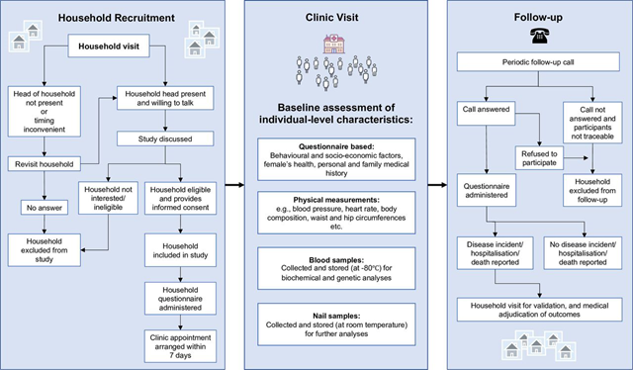
Source: XXX

Overall Aim
To describe the epidemiology of bioimpedance-derived body composition measures in adults in Bangladesh and examine their associations with the distribution and occurrence of cardiometabolic diseases using large-scale data from the BELIEVE cohort.

Research Objectives
- To describe the population distribution of bioimpedance-derived body composition measures and cardiometabolic diseases across age, sex, socioeconomic position, and urban, slum, and rural settings.
- To examine the cross-sectional associations between body composition measures and prevalent cardiometabolic diseases, including type 2 diabetes, hypertension, and multimorbidity.
- To explore associations of body composition measures with incident type 2 diabetes during follow-up.

Methods

Study design and setting
This study will use data from the BELIEVE cohort, a population-based prospective cohort study comprising 73,883 participants from 30,817 households established in Bangladesh between January 2016 and March 2020. The cohort spans three contrasting settings: urban (Mirpur, Dhaka), urban poor or slum (Bauniabadh, Dhaka), and rural (Matlab, Chandpur) (4) shown in Figure 4.
Figure 4: Location of the BELIEVE study sites.
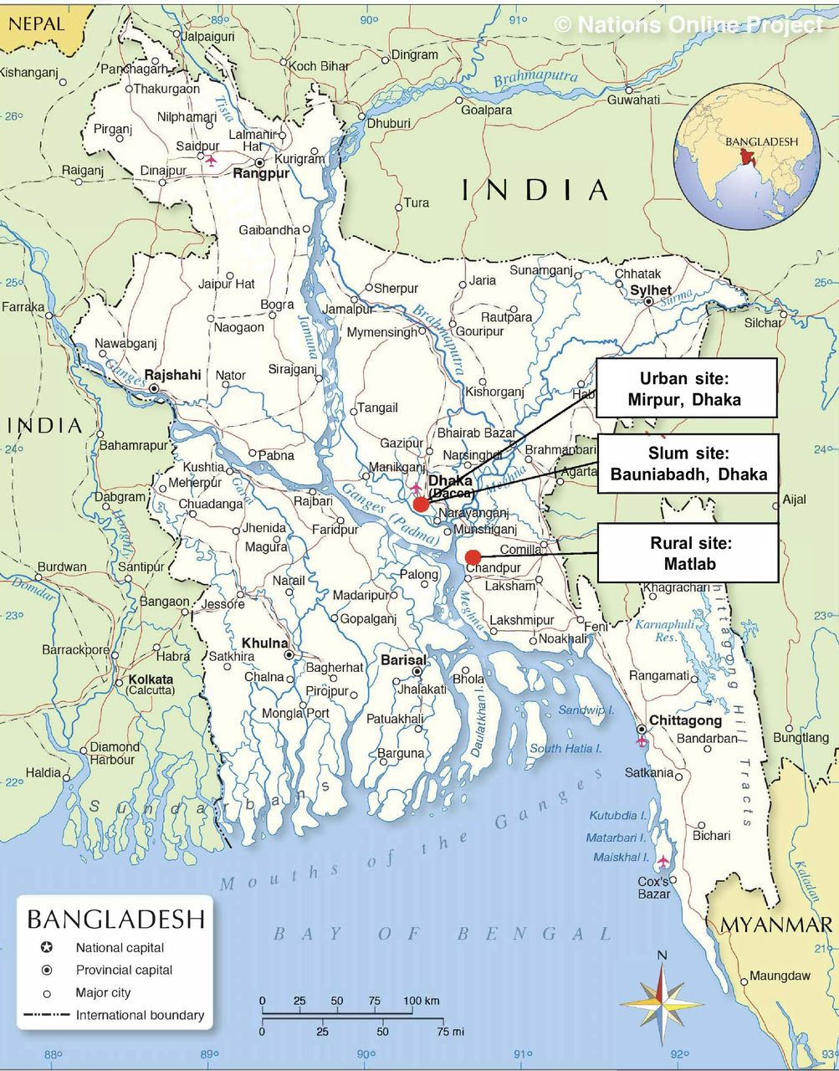
Source: XXX

Study population and follow-up
The BELIEVE cohort recruited individuals aged ≥11 years who had lived in their household for at least three years, intended to remain in the study area for a further five years, and provided written informed consent. Participants were identified through complete household surveys and invited to attend local clinics for baseline assessment.
This study will include adults aged 18 years or older with available baseline anthropometric and BIA measurements. Cardiometabolic diseases (CMDs) are well-defined in adults, and BIA measurements are less influenced by growth and pubertal development (27,35). Before analysis, data completeness and internal consistency will be assessed, and predefined data quality checks will be applied to identify biologically implausible values. Complete case analysis will inform analytic sample sizes across study objectives.
Longitudinal analyses will focus on incident type 2 diabetes, given its high burden, availability of supporting biomarkers, and ongoing outcome validation within the cohort. Individuals with type 2 diabetes at baseline will be excluded from the incidence analysis.

Exposures
Primary exposures are anthropometric and body composition measures informed by prior literature (12,36). These include height, weight, BMI, waist circumference, hip circumference, waist-to-hip ratio, body fat mass, and body fat percentage derived from BIA. Derived indices will include fat mass index, visceral adiposity indicators relevant to hypertension and insulin resistance, total body water and phase angle as an indicator of hydration and cellular integrity (36).

Outcomes
Outcomes are cardiometabolic diseases assessed at baseline and during follow-up. Prevalent outcomes include type 2 diabetes (primary) and cardiometabolic multimorbidity, defined as the presence of two or more conditions among diabetes, hypertension, and cardiovascular disease (37). Outcomes will be ascertained using self-reported medical history supplemented by medication use and available clinical measurements according to cohort protocols (33).
Incident type 2 diabetes will be analysed using time-to-event methods with follow-up time calculated from baseline recruitment to the first reported diagnosis or censoring. Where available, glycated haemoglobin (HbA1c) will be used to assess concordance with self-reported diabetes and to explore patterns of undiagnosed type 2 diabetes at baseline.

Covariates and confounders
Covariates were selected based on prior evidence (37,38). Continuous covariates will include age and education years. Systolic blood pressure (SBP) and diastolic blood pressure (DBP) will be treated as mediators. Categorical covariates include sex, study site, education level, occupation type, household income, marital status, smoking status, alcohol consumption, psychosocial factors, and a family history of cardiometabolic diseases.
Table 2 in the Appendix provides a detailed description of the variables envisaged for analysis (exposure, outcome and covariates).

Statistical analysis
All statistical analyses will be conducted in R Version 4.5.1. The base R, “tidyverse” and “ggplot2” packages will be used for statistical analysis and visualisation of results.

Assessment of normality
Normality of continuous variables will be assessed using histograms and Q-Q plots rather than the Shapiro-Wilk test or the Kolmogorov-Smirnov test, which are hypersensitive to small deviations in such large cohorts (39,40). Transformations will be applied where appropriate, and extreme outliers will be investigated and where appropriate, truncated at the 1st and 99th percentiles.

Research aim 1: Descriptive analyses
Baseline anthropometric and BIA-derived body composition measures, as well as CMD prevalence, will be summarised across sex, age groups, socioeconomic position, and study sites. Age- and sex-standardised prevalence estimates will be reported. Continuous variables will be reported as means and standard deviations (SD) or medians and interquartile ranges (IQR). Categorical variables will be presented as frequencies and percentages (31). Continuous exposures will be categorised into deciles to assess dose–response relationships without assuming linearity.

Research aim 2: Cross-sectional associations
Multivariable regression models will estimate associations between body composition measures and prevalent cardiometabolic outcomes, allowing adjustment for confounders beyond using t-tests, Kruskal-Wallis, or chi-squares(41). As both body composition measures and CMDs vary by age, sex, socioeconomic position, and study site, regression modelling will enable the estimation of independent associations of covariates and valid inference (42).
Multivariable linear regression will be used for continuous outcomes and multivariable logistic regression for binary outcomes, reporting estimates as β coefficients or odds ratios with 95% confidence intervals. Household clustering will be accounted for using mixed-effect models (linear and generalized) with household ID included as a random effect (43), accounting for shared environmental exposures (e.g., diet and air pollution).
Models will be adjusted for relevant confounders (34,44) while preserving sample size: Model 1 (age, sex, and site), Model 2 (socioeconomic variables), Model 3 (behavioural factors) and Model 4 (other anthropometric or BIA measures as appropriate). This approach allows for flexible handling of non-normal data through transformations, categorisation (e.g., deciles), and non-linear terms, rather than reliance on rank-based tests (11,39).

Model assumptions and effect modification
Model assumptions will be assessed using diagnostic plots and likelihood-based tests. Continuous variables will be transformed or categorised where required, and non-linear terms introduced if linearity assumptions are violated. Model fit will be evaluated using the Akaike Information Criterion and adjusted R-squared. Effect modification by sex, age group, socioeconomic position, and study site will be examined using interaction terms and stratified analyses.
My final choice of modelling strategies may be refined after accessing the data and attending advanced biostatistics classes.

Research aim 3: Longitudinal analyses
Cox proportional hazard models will examine associations between baseline body composition measures and incident type 2 diabetes. Hazard ratios with 95% confidence intervals will be interpreted cautiously, as incident outcomes are currently self-reported and validation is ongoing. Models will be adjusted for age, sex, socioeconomic status and other anthropometic or BIA measures as relevant, with the Akaike Information Criterion (AIC) used to determine the most informative model including body composition variables (45,46). Robust standard errors or frailty models will be used to account for household-level clustering (47). Predictive value of alternative models will secondarily be compared using the Harrell’s C-index.

Cox Proportional Hazards Assumptions
Proportional hazards assumptions will be assessed using Schoenfeld residuals, with non-informative censoring assumed. Sensitivity analyses will exclude participants with baseline cardiometabolic disease or on relevant medications.

Handling of missing data
Patterns and extent of missing data will be examined using descriptive summaries and visualised using the “md.pattern” function in the “mice” package (48), stratified by age, sex, and study site. Initial analyses will use complete case analysis (CCA) to assess the potential impact of missingness on estimates (49). If missingness is substantial and compatible with a missing at random (MAR) assumption, multiple imputation will be considered.
Directed acyclic graphs will guide variable selections and assumptions evaluation required for multiple imputation. Predictive mean matching will be applied for continuous variables, logistic regression for binary variables, and multinomial logistic regression for categorical variables (50).
I expect to develop a clearer strategy after looking at the data and further self-study of using R for this task.

Discussion
This study advances understanding of body composition patterns and their cardiometabolic correlates across urban, slum, and rural settings in Bangladesh using the BELIEVE cohort. By moving beyond BMI, it provides a more nuanced assessment of cardiometabolic risk in a South Asian LMIC context. The strengths of the study include: 1) a large prospective population-based sample with a range of socioeconomic, psychosocial, behavioural, and biological variables to be examined and alongside standardised anthropometric and BIA measurements in a South Asian LMIC setting where such data are scarce, 2) Ability to examine multimorbidity, and early disease onset across demographic strata, 3) Self-reported CMDs can be validated through medical records and biological markers. 4) The prospective design allows analyses of incident type 2 diabetes, allowing temporal interpretation.
However, limitations include 1) BIA estimates are sensitive to hydration status, recent food intake, and physical activity, which may introduce measurement error. 2) Prediction equations for body composition may require further validation in South Asian populations. 3) Some outcomes are still undergoing validation, limiting the scope and reliability of longitudinal analyses. 4) Outcome misclassification may occur due to undiagnosed diabetes or episodic blood pressure elevation, 5) the cohort involved voluntary participation of invited households, hence it is not nationally representative, however, its internal heterogeneity supports generalisability to similar settings, and 6) Reverse causality limits causal inference for cross-sectional associations.
Overall, this study provides novel contribution to understanding multidimensional determinants of cardiometabolic risk in an understudied South Asian LMIC population, informing more accurate risk stratification and context-specific prevention strategies.

Risk assessment and contingency plans
The potential risks to my study completion that I have identified, and their contingency plans are detailed in Table 1.
Table 1: Risk and contingency plans
Risk | Likelihood | Severity | Contingency plan
Delays in dataset access due to the ongoing cohort .validation | High | Medium | I have worked with my supervisor to fill in the data request sheet. However, I acknowledge that this is going to be updated because validation is ongoing and may influence my variables.
Insufficient statistical expertise for planned analyses | Low | Medium | Most of my intended statistical analysis techniques will be covered in the Advanced Biostatistics for Epidemiology module later in the term. I will also be frequently checking with my supervisor, who is a statistician on my statistical methods.
Coding or software competency | Low | High | I am self-studying on how to handle, clean large datasets with R.  I have created a Git repository for my dissertation project and will ensure that code and other essential documents will always be backed.
Insufficient data for intended incident analysis | Low-medium | High | I have scheduled regular meetings with my supervisor to discuss data feasibility and adjustment of my research question
Personal emergencies or illness | Low | Low | I am accounted for additional time for my dissertation as reflected in my Gantt chart

Timeline
To allow for better visualization of the timeline of the dissertation, a Gantt chart has been created below

Appendix

Table 2: Detailed Variables and Covariates
Variable_name | Role | Type | Categories
A. Exposure Variables
height (ht / height_bc) | Exposure | Continuous | —
weight (wt / weight_bc) | Exposure | Continuous | —
BMI (bmi / bmi_bc) | Exposure | Continuous / Categorical | Underweight / Normal / Overweight / Obese
waist circumference (waist / waist_bc) | Exposure | Continuous | —
hip circumference (hip / hip_bc) | Exposure | Continuous | —
Waist-Hip Ratio (whr / whr_bc) | Exposure | Continuous | —
Fat mass (fatm_bc) | Exposure | Continuous | —
Body fat % (fatp_bc) | Exposure | Continuous | —
Visceral fat level (vfatl_bc / viszfat_bc) | Exposure | Continuous | —
Fat-free mass (ffm_bc) | Exposure | Continuous | —
Intracellular water (icw_bc) | Exposure | Continuous | —
Extracellar water (ecw_bc) | Exposure | Continuous | —
Total body water (tbw_bc) | Exposure | Continuous | —
Body water mass (waterm_bc) | Exposure | Continuous | —
Body water % (waterp_bc) | Exposure | Continuous | —
Bone mass (bonem_bc) | Exposure | Continuous | —
Phase angle (phaseangle_bc) | Exposure | Continuous | —
Basal metabolic rate (bmr_bc) | Exposure | Continuous | —
B. Outcome Variables
Type 2 diabetes (hxdiab2) | Outcome | Binary | Yes / No
Age at diabetes diagnosis (hxdiab2age) | Outcome | Continuous / Categorical | <40 vs ≥40
Hypertension (hxhyp) | Outcome | Binary | Yes / No
Age at hypertension diagnosis (hxhypage) | Outcome | Continuous / Categorical | <40 vs ≥40
Cardiovascular disease (hxcvd) | Outcome | Binary | Yes / No
Multimorbidity (≥2 conditions) | Outcome | Categorical | 0(<2) / 1(≥2)
Incident diabetes (ep1_diab2) | Outcome | Binary (time-to-event) | Event / No event
C. Covariates
Age (aqage) | Covariate | Continuous | —
Sex (gender) | Covariate | Binary | Male / Female
Site | Covariate | Categorical | Urban / Slum / Rural
Education level (edlevel) | Covariate | Categorical | None / Primary / Secondary / Tertiary
Education years (edyrs) | Covariate | Continuous | —
Marital status (married) | Covariate | Binary | Yes / No
Occupation (occjob) | Covariate | Categorical | Employed / Self / Unemployed
Income (wagecont1/2) | Covariate | Continuous / Categorical | Quintiles
Smoking (smokstat) | Covariate | Categorical | Never / Former / Current
Tobacco chewing (chewstat) | Covariate | Binary | Yes / No
Alcohol use (alcallstat) | Covariate | Categorical | Never / Former / Current
Anti-hypertensive use (hypdstat) | Covariate | Binary | Yes / No
Anti-diabetic use (diadstat) | Covariate | Binary | Yes / No
Family history of CVD (hxcvd_f) | Covariate | Binary | Yes / No
Family history of diabetes (hxdiab_f) | Covariate | Binary | Yes / No
Systolic BP (sbp / bpsys_bc) | Outcome / Covariate | Continuous | —
Diastolic BP (dbp / bpdia_bc) | Outcome / Covariate | Continuous | —
Pulse rate (pulse / pulse_bc) | Covariate | Continuous | —

References
1. Benziger CP, Roth GA, Moran AE. The Global Burden of Disease Study and the Preventable Burden of NCD. Glob Heart [Internet]. 2016 Dec 1 [cited 2025 Dec 29];11(4). Available from: https://globalheartjournal.com/articles/10.1016/j.gheart.2016.10.024
2. Stark BA, DeCleene NK, Desai EC, Hsu JM, Johnson CO, Lara-Castor L, et al. Global, Regional, and National Burden of Cardiovascular Diseases and Risk Factors in 204 Countries and Territories, 1990-2023. JACC. 2025 Dec 2;86(22):2167–243.
3. Patel AP, Wang M, Kartoun U, Ng K, Khera AV. Quantifying and Understanding the Higher Risk of Atherosclerotic Cardiovascular Disease Among South Asian Individuals. Circulation. 2021 Aug 10;144(6):410–22.
4. Chowdhury R, Khan N, Pennells L, Iurilli MLC, Uddin Miah MT, Monower MM, et al. Cohort profile: the BangladEsh Longitudinal Investigation of Emerging Vascular and nonvascular Events (BELIEVE) cohort study. BMJ Open. 2025 Jan 22;15(1):e088338.
5. Balaji K, Chahil V, Shakoor A, Kalra D, Vijayaraghavan K. Inflammation and cardiometabolic disease in South Asians: The fire and fire tenders. J Clin Lipidol [Internet]. 2025 Nov 6 [cited 2026 Jan 7]; Available from: https://www.sciencedirect.com/science/article/pii/S1933287425004970
6. Appropriate body-mass index for Asian populations and its implications for policy and intervention strategies. The Lancet. 2004 Jan 10;363(9403):157–63.
7. Lalnuneng A. Is BMI Enough? Body Composition Profiles and Cardiometabolic Risk in Hmar Tribe of Northeast India. J Racial Ethn Health Disparities. 2025 Oct 17;
8. Lee MJ, Kim J. The pathophysiology of visceral adipose tissues in cardiometabolic diseases. Biochem Pharmacol. 2024 Apr;222:116116.
9. Omura-Ohata Y, Son C, Makino H, Koezuka R, Tochiya M, Tamanaha T, et al. Efficacy of visceral fat estimation by dual bioelectrical impedance analysis in detecting cardiovascular risk factors in patients with type 2 diabetes. Cardiovasc Diabetol. 2019 Oct 22;18:137.
10. Kang S, Kyung C, Park JS, Kim S, Lee SP, Kim MK, et al. Subclinical vascular inflammation in subjects with normal weight obesity and its association with body fat: an 18 F-FDG-PET/CT study. Cardiovasc Diabetol. 2014 Apr 4;13:70.
11. Kim JY, Han SH, Yang BM. Implication of high-body-fat percentage on cardiometabolic risk in middle-aged, healthy, normal-weight adults. Obesity. 2013;21(8):1571–7.
12. Shea JL, King MTC, Yi Y, Gulliver W, Sun G. Body fat percentage is associated with cardiometabolic dysregulation in BMI-defined normal weight subjects. Nutr Metab Cardiovasc Dis NMCD. 2012 Sept;22(9):741–7.
13. Correa-Rodriguez M, Gonzalez-Ruiz K, Rincon-Pabon D, Izquierdo M, Garcia-Hermoso A, Agostinis-Sobrinho C, et al. Normal-Weight Obesity Is Associated with Increased Cardiometabolic Risk in Young Adults. Nutrients. 2020 Apr;12(4):1106.
14. Lahav Y, Kfir A, Gepner Y. The paradox of obesity with normal weight; a cross-sectional study. Front Nutr. 2023;10:1173488.
15. Global Burden of Cardiovascular Diseases and Risks 2023 Collaborators. Global, Regional, and National Burden of Cardiovascular Diseases and Risk Factors in 204 Countries and Territories, 1990-2023. JACC. 2025 Dec 2;86(22):2167–243.
16. Khanam F, Hossain MdB, Mistry SK, Afsana K, Rahman M. Prevalence and Risk Factors of Cardiovascular Diseases among Bangladeshi Adults: Findings from a Cross-sectional Study. J Epidemiol Glob Health. 2019 Sept;9(3):176–84.
17. Kapoor N, Furler J, Paul TV, Thomas N, Oldenburg B. Normal Weight Obesity: An Underrecognized Problem in Individuals of South Asian Descent. Clin Ther. 2019 Aug 1;41(8):1638–42.
18. Mohan I, Gupta R, Misra A, Sharma KK, Agrawal A, Vikram NK, et al. Disparities in Prevalence of Cardiometablic Risk Factors in Rural, Urban-Poor, and Urban-Middle Class Women in India. PLoS ONE. 2016 Feb 16;11(2):e0149437.
19. Andretti B., Atanasova P., Verdun Z., Wellappuli N.T., Pradeepa R., Vasudevan S., et al. Income-based inequalities in risk factors of NCDs and inequities of preventive care services amongst 202,682 adults: a cross-sectional study of South Asia Biobank. BMC Med. 2025;23(1):504.
20. Fatema K, Zwar NA, Milton AH, Ali L, Rahman B. Prevalence of Risk Factors for Cardiovascular Diseases in Bangladesh: A Systematic Review and Meta-Analysis. PLOS ONE. 2016 Aug 5;11(8):e0160180.
21. Kyle UG, Bosaeus I, De Lorenzo AD, Deurenberg P, Elia M, Gómez JM, et al. Bioelectrical impedance analysis--part I: review of principles and methods. Clin Nutr Edinb Scotl. 2004 Oct;23(5):1226–43.
22. Pourshahidi LK, Wallace JMW, Mulhern MS, Horigan G, Strain JJ, McSorley EM, et al. Indices of adiposity as predictors of cardiometabolic risk and inflammation in young adults. J Hum Nutr Diet. 2016 Feb;29(1):26–37.
23. Hoffmann J, Thiele J, Kwast S, Borger MA, Schröter T, Schmidt J, et al. A new approach to quantify visceral fat via bioelectrical impedance analysis and ultrasound compared to MRI. Int J Obes. 2024 Feb;48(2):209–17.
24. de Góes Pacheco AL, Santos GCJ, Leão Costa DM, Cavalcanti Fraga JV, Sacramento HS, Manoel da Costa J, et al. Error reduction as a calibration strategy for body composition measurements: A comparison between bioelectrical impedance analysis and dual-energy X-ray absorption. Clin Nutr ESPEN. 2026 Feb 1;71:102843.
25. Böhm A, Heitmann BL. The use of bioelectrical impedance analysis for body composition in epidemiological studies. Eur J Clin Nutr. 2013 Jan;67(1):S79–85.
26. Houtkooper LB, Lohman TG, Going SB, Howell WH. Why bioelectrical impedance analysis should be used for estimating adiposity. Am J Clin Nutr. 1996 Sept;64(3 Suppl):436S-448S.
27. Wells JCK. Ethnic variability in adiposity, thrifty phenotypes and cardiometabolic risk: addressing the full range of ethnicity, including those of mixed ethnicity. Obes Rev Off J Int Assoc Study Obes. 2012 Dec;13 Suppl 2:14–29.
28. Polcrova A, Pavlovska I, Maranhao Neto GA, Kunzova S, Infante-Garcia MM, Medina-Inojosa JR, et al. Visceral fat area and cardiometabolic risk: The Kardiovize study. Obes Res Clin Pract. 2021 July 1;15(4):368–74.
29. Katchunga PB, Bapolisi AM, M’Buyamba-Kabangu JR, Hermans MP. Bioelectrical impedance outperforms waist circumference for predicting cardiometabolic risk in Congolese hypertensive subjects: a cross-sectional study. BMC Cardiovasc Disord. 2015 Mar 10;15(1):17.
30. Kistan J, Wing J, Tshabalala K, Van Hougenhouck-Tulleken W, Basu D. Body composition estimates from bioelectrical impedance and its association with cardiovascular risk. Afr J Prim Health Care Fam Med. 2024 Oct 9;16(1):e1–4.
31. Byambasukh O, Eisenga MF, Gansevoort RT, Bakker SJ, Corpeleijn E. Body fat estimates from bioelectrical impedance equations in cardiovascular risk assessment: The PREVEND cohort study. Eur J Prev Cardiol. 2019 June;26(9):905–16.
32. He X, Zhu Z, Zang J, Wang Z, Liao P, Wang W, et al. Percent body fat, but not body mass index, is associated with cardiometabolic risk factors in children and adolescents. Chronic Dis Transl Med. 2023 June;9(2):143–53.
33. Lamb MJE, Byrne CD, Wilson JF, Wild SH. Evaluation of Bioelectrical Impedance Analysis for Identifying Overweight Individuals at Increased Cardiometabolic Risk: A Cross-Sectional Study. PLOS ONE. 2014 Sept 22;9(9):e106134.
34. Fan L, Qiu J, Zhao Y, Yin T, Li X, Wang Q, et al. The association between body composition and metabolically unhealthy profile of adults with normal weight in Northwest China. PloS One. 2021;16(3):e0248782.
35. Silva AM, Campa F, Stagi S, Gobbo LA, Buffa R, Toselli S, et al. The bioelectrical impedance analysis (BIA) international database: aims, scope, and call for data. Eur J Clin Nutr. 2023 Dec;77(12):1143–50.
36. Popiolek-Kalisz J, Szczygiel K. Bioelectrical Impedance Analysis and Body Composition in Cardiovascular Diseases. Curr Probl Cardiol. 2023 Nov;48(11):101911.
37. Tian Z, Yang L, Li Y, Huang Y, Yang J, Xue F. Associations of different insulin resistance-related indices with the incidence and progression trajectory of cardiometabolic multimorbidity: a prospective cohort study from UK biobank. Cardiovasc Diabetol. 2025 June 18;24(1):257.
38. Ashwell M, Gibson S. Waist-to-height ratio as an indicator of ‘early health risk’: simpler and more predictive than using a ‘matrix’ based on BMI and waist circumference. BMJ Open. 2016 Mar 14;6(3):e010159.
39. Ghasemi A, Zahediasl S. Normality Tests for Statistical Analysis: A Guide for Non-Statisticians. Int J Endocrinol Metab. 2012;10(2):486–9.
40. Altman DG, Bland JM. Statistics notes: The normal distribution. 1995 Feb 4 [cited 2026 Jan 10]; Available from: https://www.bmj.com/content/310/6975/298
41. Vander Weele TJ, Shpitser I. A New Criterion for Confounder Selection. Biometrics. 2011 Dec 1;67(4):1406–13.
42. Greenland S, Senn SJ, Rothman KJ, Carlin JB, Poole C, Goodman SN, et al. Statistical tests, P values, confidence intervals, and power: a guide to misinterpretations. Eur J Epidemiol. 2016 Apr 1;31(4):337–50.
43. Diez-Roux AV. Multilevel Analysis in Public Health Research. Annu Rev Public Health. 2000 May 1;21(Volume 21, 2000):171–92.
44. von Elm E, Altman DG, Egger M, Pocock SJ, Gøtzsche PC, Vandenbroucke JP. The Strengthening the Reporting of Observational Studies in Epidemiology (STROBE) statement: guidelines for reporting observational studies. The Lancet. 2007 Oct 20;370(9596):1453–7.
45. Steyerberg EW, Vickers AJ, Cook NR, Gerds T, Gonen M, Obuchowski N, et al. Assessing the performance of prediction models: a framework for some traditional and novel measures. Epidemiol Camb Mass. 2010 Jan;21(1):128–38.
46. Therneau TM, Grambsch PM. The Cox Model. In: Therneau TM, Grambsch PM, editors. Modeling Survival Data: Extending the Cox Model [Internet]. New York, NY: Springer; 2000 [cited 2026 Jan 20]. p. 39–77. Available from: https://doi.org/10.1007/978-1-4757-3294-8_3
47. Austin PC. A Tutorial on Multilevel Survival Analysis: Methods, Models and Applications. Int Stat Rev Rev Int Stat. 2017 Aug;85(2):185–203.
48. Lee KJ, Tilling KM, Cornish RP, Little RJA, Bell ML, Goetghebeur E, et al. Framework for the treatment and reporting of missing data in observational studies: The Treatment And Reporting of Missing data in Observational Studies framework. J Clin Epidemiol. 2021 June;134:79–88.
49. Ross RK, Breskin A, Westreich D. When Is a Complete-Case Approach to Missing Data Valid? The Importance of Effect-Measure Modification. Am J Epidemiol. 2020 June 30;189(12):1583–9.
50. RUBIN DB. Inference and missing data. Biometrika. 1976 Dec 1;63(3):581–92.

Common etiological factors associated with CVDs in South Asian populations. Adapted from "Prevalence of Cardiovascular Diseases in South Asians: Scrutinizing Traditional Risk Factors and Newly Recognized Risk Factors Sarcopenia and Osteopenia/Osteoporosis," by V. S. Kumar, M. Gupta, and S. Kumar, 2023, Disease-a-Month, 69(12), Article 101625
Body composition measures as determined by BIA. Adapted from "Bioelectrical Impedance Analysis in Monitoring of the Clinical Status and Diagnosis of Diseases," by Analog Devices, 2024, Analog Devices Technical Articles

